NAME: **Muhammad Shoaib Akhter Qadri** REG NO: **79290**

CLASS: **BSE-5(B)** SHIFT: **Morning**

INSTRUCTOR: **QAMARUDDIN MEMON**

COURSE TITLE: **Embedded Systems** COURSE CODE: **CEN 439**

QUESTION # 01

Design an embedded system in which LM35 is connected with analog pins of a microcontroller that measures the atmospheric temperature on an LCD screen.

Diagram:

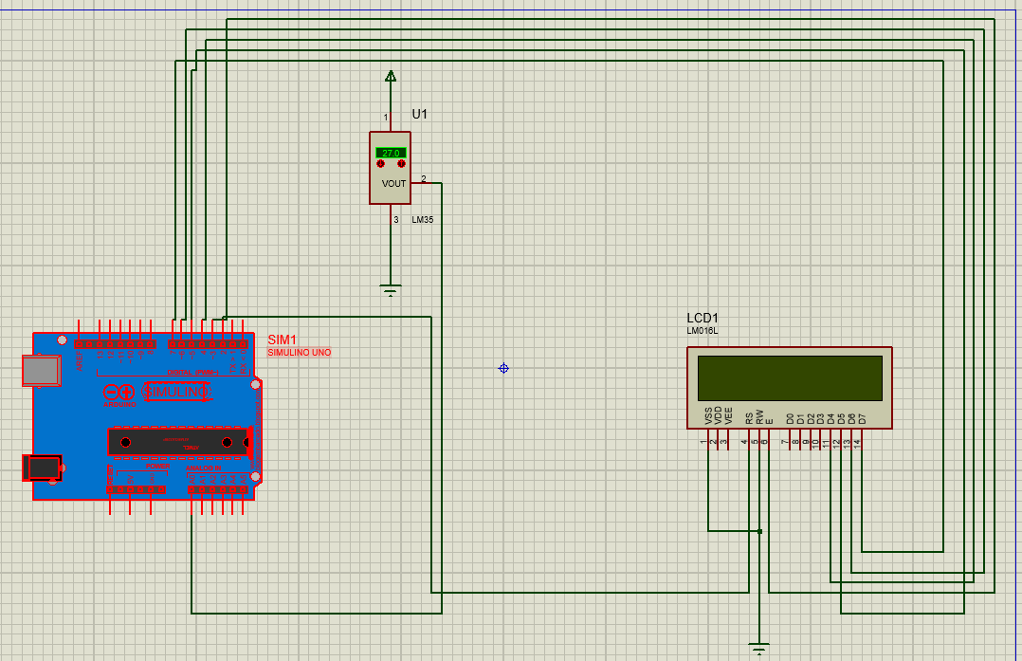



Code:

# include "LiquidCrystal.h"

const int rs = 2, en = 3, d4 = 4, d5 = 5, d6 = 6, d7 = 7;

LiquidCrystal lcd(rs, en, d4, d5, d6, d7);

float temp;

void setup() {

Serial.begin(9600);

analogReference(INTERNAL);

lcd.begin (16,2);

lcd.setCursor(0, 0);

lcd.setCursor(0, 1);

delay(400);

delay (700);

lcd.clear();

}

void loop() {

temp = analogRead(A0);

temp=temp*1100/(1024*10);

lcd.print("TEMP: ");

lcd.print(temp);

lcd.println("*C");

delay(500);

lcd.clear();

}

QUESTION # 02

Design an embedded system in which variable resistor connect with analog pins of the microcontroller, which takes voltage from vcc pin of 3.75V, and measure the analog value from the microcontroller. Further LCD displayed the supply voltage, and its analog value and then mapped the analog value into voltage form. Finally, measure its error between supply and measure analog value.

Diagram:

Code:

int sensorPin = A0; float voltage;

#include <LiquidCrystal.h>

LiquidCrystal lcd(12, 11, 5, 4, 3, 2); void setup() {

lcd.begin(16, 2);

lcd.print("VariableResistor Voltage:");

}

void loop() {

voltage = analogRead(sensorPin) * 5.0 / 1024.0;

lcd.setCursor(0, 1);

lcd.print(voltage); lcd.print(" V"); delay(100);}

QUESTION # 03

Design an embedded system in which LDR connected with analog pins of microcontroller that measure the intensity of the light LCD screen.

Diagram:

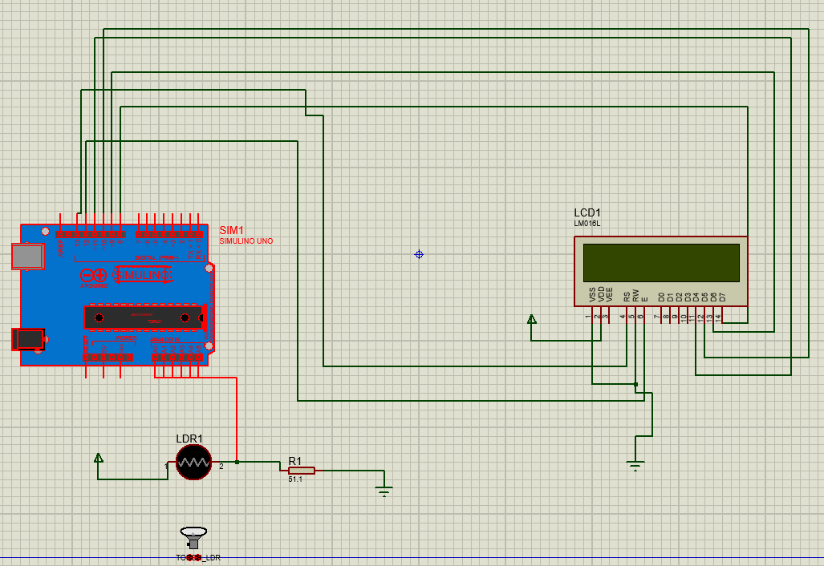

Code:

#include <LiquidCrystal.h>

LiquidCrystal lcd (13, 12, 11, 10, 9, 8);

void setup() {

lcd.begin(16, 2);

}

void loop(){

int ldr = analogRead(A0);

lcd.setCursor(0,0);

lcd.print("LDR Value:");

lcd.setCursor(0,1);

lcd.print(ldr);

}

QUESTION # 04

Design an embedded system in which ultrasonic sensor connect with analog pins of microcontroller that measure the distance of the object LCD Screen.

Diagram:

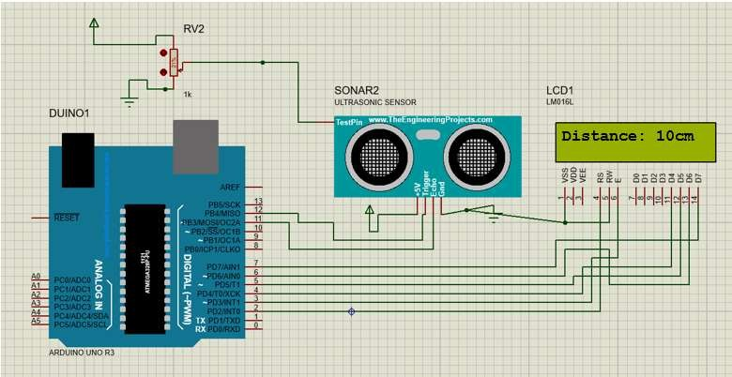

Code:

#include <NewPing.h>

#include <LiquidCrystal.h> const int TRIG_PIN = 7; const int ECHO_PIN = 8;

NewPing sonar(TRIG_PIN, ECHO_PIN, MAX_DISTANCE);

LiquidCrystal lcd(12,11,5,4,3,2); void setup() {

Serial.begin(9600); pinMode(TRIG_PIN, OUTPUT); pinMode(ECHO_PIN, INPUT);

lcd.begin(16, 2);

}

void loop() { digitalWrite(TRIG_PIN, LOW); delayMicroseconds(2); digitalWrite(TRIG_PIN, HIGH); delayMicroseconds(10); digitalWrite(TRIG_PIN, LOW);

long duration = pulseIn(ECHO_PIN, HIGH); float distance = duration * 0.034 / 2; lcd.clear();

lcd.setCursor(0,0); lcd.print("Distance: "); lcd.print(distance); lcd.print(" cm"); delay(1000);

}

QUESTION # 05

Design an embedded system in which PIR sensor connect with analog pins of microcontroller that measure the motion of the object and displayed on LCD.

Diagram:

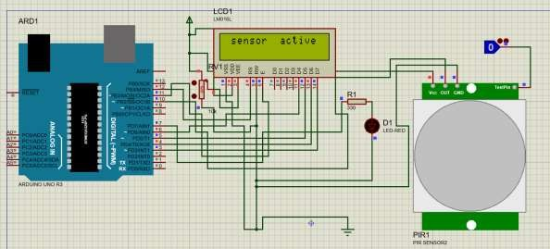

Code:

#include <LiquidCrystal.h> LiquidCrystal lcd(12,11,6,5,4,3); int motionTime = 2;

long unsigned int lowPin;

long unsigned int pause = 5000; boolean lockLow = true; boolean takeLowTime;

int pirPin = 10; int ledPin = 7; void setup(){

digitalWrite(pirPin, LOW); pinMode(pirPin, INPUT); pinMode(ledPin, OUTPUT); lcd.begin(16,2); lcd.setCursor(1,0); lcd.print("motion detector"); delay(500);

for(int i = 0; i < motionTime; i++){ lcd.print(i);

delay(1000); lcd.clear();

}

lcd.clear(); lcd.setCursor(1,0); lcd.print("sensor");

lcd.print("active"); delay(500);

}

QUESTION # 06

Design an embedded system in which soil moisture sensor connect with analog pins of microcontroller which measure the intensity of water on soil and display on LCD.

Code:

#include <LiquidCrystal.h>

LiquidCrystal lcd(13, 12, 11, 10, 9, 8);

int SensorPin = A5;

void setup() {

lcd.begin(20, 4);

// Print a message to the LCD.

lcd.setCursor(0,0);

lcd.print("----INFOTAINMENT----");

lcd.setCursor(0,1);

lcd.print("SOIL MOISTURE LEVEL.");

lcd.setCursor(2,2);

lcd.print("Analog Value: ");

lcd.setCursor(2,3);

lcd.print("Output: ");

}

void loop() {

int SensorValue = analogRead(SensorPin);

float SensorVolts = analogRead(SensorPin)*0.0048828125;

lcd.setCursor(16, 2); lcd.print(SensorValue);

lcd.setCursor(9, 3);

lcd.print(SensorVolts);

lcd.print("V");

delay(1000);}

Diagram:

